The Amazelingtons Present
A Snail’s Pace
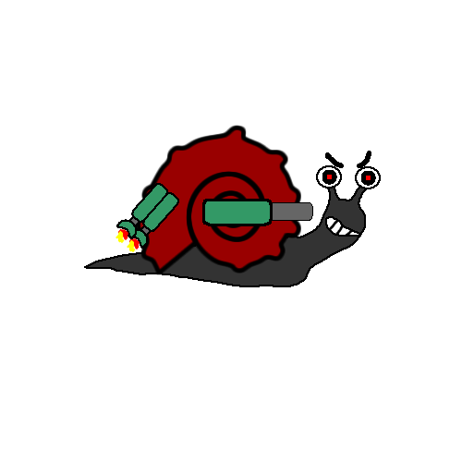

Introduction

Team Name: The Amazelingtons
Members:
Name | Major
Joseph Andrusyszyn | Software Engineering
Patrick Dobson | Information Technology
Joshua Gruenberg | Software Engineering
John Reese | Software Engineering
Brian Schroth | Software Engineering

Game Overview
A Snail’s Pace is a cross pollination of the shooter and platformer genres. It centers around a snail named Helix who has acquired a jetpack and a gun, and he decides to kill garden variety enemies(pun intended) and oppressive bosses. The game will combine platformer elements – running and jumping to avoid enemies – and shooter elements. The controls will use an intuitive mouse/keyboard interface that the user will employ to make Helix “fly”, walk, and kill enemies.
To create this game, the Amazelingtons will work in XNA 2.0 and C# while using Lua for map definitions, character behaviors, and configuration files. This document contains a class diagram as well as an outline of milestones for the development of the project.

Game Concept

Background Story
Helix has mysteriously discovered a bio-fuel jetpack that is powered by the slime that his snail skin naturally excretes. Even luckier, Helix has also discovered a highly effective machine gun. As a result of his good fortune, Helix decides to go vigilante and destroy all the insects he can find.

Helix
The genus that most commonly refers to snails is Helix, thus the hero’s name. As a snail, Helix can only crawl on his stomach. With the addition of his newly found bio-fuel jetpack, Helix is able to fly for a limited period of time. When his jetpack runs out of bio-fuel, he can’t fly until he replenishes. He wields a machine gun that allows him to kill his enemies. Helix is a crawling, flying, machine gun wielding snail vigilante.

Enemies
During his adventure, Helix will encounter a variety of enemies. Here is a list of each enemy with their attributes.
Enemy | Power | Modus Operandi | Description
Fire/Worker Ants | Low | Save the Queen! Kill the snail! | Ants are average difficulty walking enemies. Depending on type, they may shoot fire or dirt.
Bee | Medium | That stupid snail is in my way! | Bees fire their stingers at Helix. They fly and can be pesky.
Spider | High | Hunger! Snails are delicious. | Besides being strong, spiders can also spin webs that Helix may have to negotiate. They also spit venom.
Gnats | Low | Kill everything! Our lives mean nothing! | Gnats are suicide bombers. They will slow Helix down and damage anything in their path.
Ant Queen | High | Helix is a threat to my domain! | The Ant Queen can produce other ants at her will. She also spits venom.
Salt Shaker | High | Absorb! Absorb! Absorb! | The final boss is truly dangerous. He will sap the life juices out of Helix with his endless grains of salt

Core Gameplay
A Snail's Pace is a platform game with a heavy dose of shooter mixed in. Level design will be done like a typical platformer, where there will be obstacles and enemies in your path to reach the goal at the right of the map, but rather than making the character jump on enemies, he will have a gun, able to shoot anywhere in a 360 degree radius. And since snails are unable to jump, he has been fitted with a jetpack, to help with any aerial maneuvers necessary.

For A Snail's Pace to work as a game, we need to nail two basic things: Moving, and shooting. Moving left to right must work smoothly, as well as moving in the air when the jetpack is engaged. The gun must be easy to control and shoot at the desired target, and the target must react appropriately when hit. This will require precise collision detection for bullets on both your character and any enemies. We want players to be challenged and need to wade through lots and lots of bullets, if controls were not tight and collision detection was imprecise, this would quickly turn into a frustrating nightmare.

Game Flow
Since we are only designing one level, the curve in difficulty may be quicker than it would if it was a full product, but it should still be manageable. The game will start with basic enemies, then as the level progresses they will become tougher or at least more numerous, and finally when the end is reached, there will be a tough showdown.

Controls
The controls for A Snail's Pace are intended to be as intuitive as possible, and with some degree of configuration available for those with alternate needs. The character's motion is controlled by the keyboard, with the jet pack automatically becoming enabled when the character is told to move up, and automatically disabled when it runs out of fuel or the character lands on the ground. The aim of the gun is controlled by the mouse cursor. Firing of the gun can be controlled by mouse click or key press.

Character Abilities
A Snail's Pace contains a variety of character types, each with their own unique abilities.

Helix
The player's character, Helix, has the abilities you would expect from any jet pack totting snail, as well as some you might not. He is capable of sliding along most surfaces, including up and down steep inclines. His shell-mounted gun is capable of being aimed and fired in any direction. He can use his jet pack to propel himself upward, forward, and backward. While his jet pack is ignited, he can tuck himself inside his shell to prevent the flames from hitting his body. Tucking himself within his shell also allows him to reduce the damage he takes from long falls. When the jet pack is off, he can re-fuel it by excreting a bio-fuel into the fuel tank.

Fire Ants
Fire ants walk along just about any surface, including up and down steep inclines. They are capable of attacking by spitting fire from their mouths a short distance directly in front of themselves.

Worker Ants
Worker ants walk along just about any surface, including up and down steep inclines. They are capable of attacking by throwing chunks of dirt towards their enemies.

Ant Queen
The Ant Queen is capable of creating other ants. If her life is threatened, she is also capable of destroying parts of her tunnels to ward off attackers.

Bees
Bees move by flying through the air. They can attack their enemies by launching their stingers. After launching a stinger, a bee can quickly grow a new one.

Spiders
Spiders move by crawling up plants and across the ground. They spin webs to block the path of other creatures. If an enemy gets too close, they can also defend themselves by spitting poisonous venom.

Gnats
Gnats move by flying through the air. They act as collectives, willing to commit suicide to damage enemies to protect others.

Salt Shaker
The Salt Shaker is carried around by a human hand. It can attack snails by spilling it's contents upon them.

Technical Details

Microsoft C# with XNA 2.0
A Snail's Pace will target Microsoft's XNA 2.0 framework for video games, and will utilize C# as the primary language for the application. Builds will be handled completely by Visual C# Express 2005, and will be tested on Windows XP service pack 2 and Windows Vista.

Lua Scripting Language
To simplify the process of creating content for the game, Lua will be used as a scripting language to handle defining and implementing the characteristics and behaviors the game map, as well as the characters and their weapons.
The game engine will be written in C# with a set of base classes that define a generic set of attributes and possible behaviors, and the map and its contained characters will be defined and instantiated at the time of loading the map.
The use of Lua will allow for a simple and dynamic feature set for maps and characters. For instance, maps will be able to define a region as a “trigger point” that can call an arbitrary Lua function whenever the player character enters the trigger box.
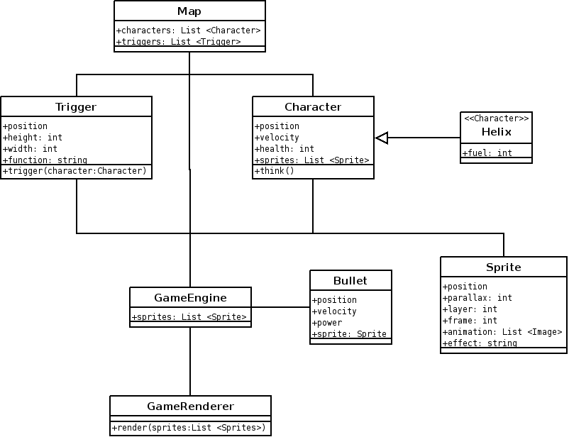
This type of dynamic behavior, coupled with ability to change Lua scripts without recompiling, will allow for flexible map design and creation, and will allow testing and immediate modification without waiting for the game to recompile and reload before seeing changes.

Class Diagram

Project Time Line

The functional requirements for this project have been grouped into sets of related features. These sets will be milestones for the project's development. The first milestones contain the most important, highest risk features. Later milestones consist of less important, lower risk features. This will enable the less important features to be dropped from the project if the higher risk features prove to be more difficult than expected.

The release time line for A Snail's Pace is as follows:

Version 0.1- 01/11/08
- Basic window frame with transparent sprites and movement.
- Configuration of window preferences (resolution, fullscreen, etc) and controls loaded from configuration files.
- Finish system architecture design

Version 0.2- 01/18/08
- Basic game engine that renders sprites with a z-buffer and parallax effects.
- Implement safe Lua interpreter

Version 0.3- 01/28/08
- Collision Detection
- Walls
- Gravity
- Character Movement

Version 0.4- 02/10/08
- Animations
- Shooting
- Basic NPC AI

Version 0.5- 02/17/08
- UI menus
- Pause
- Heads Up Display of health/fuel
- Player stat tracking (kill count, accuracy, etc)

Version 1.0- 02/20/08
- Music
- Sound Effects

Artwork and Sound

The game concept and storyline for A Snail's Pace are humorous and absurd. To fit this, the artwork for the game will follow a cartoon style. Audio for A Snail's Pace will be produced by Simon G, a professional sound recording artist and a friend and past collaborator of a team member. The game will include both background music and sound effects.

Concept Art
Helix

